# **Section 1:**

# **Pseudocode and Design of Flow Charts**

1. Finding the average of three numbers.

**Sequential Problems**

1. Find the area of a Rectangle
2. Calculate the Interest of a Bank Deposit (formula "Interest=Amount*Years*Rate/100)
3. Convert Temperature from Fahrenheit (℉) to Celsius (℃) (formula C=5/9*(F-32))
4. Make a program that calculates the total of a retail sale. The program should ask the user for the following: the retail price of the item being purchased and the sales tax rate. Once the information has been entered the program should calculate and display the following: the sales tax for the purchase and the total sale.
5. Write a program that calculates the current balance in a savings account. The program should obtain from the user the following information: the starting balance, the total amount of deposits made, and the total amount of withdrawals made. After the program has calculated the current balance, it should be displayed on the screen. Assume one input for deposits and one input for withdrawals. Draw the flowchart for this pseudo-code
6. Draw a flowchart to match the following pseudo-code.
   * Give variable num1 a starting value of 5
   * Give variable num2 a starting value of 10
   * Add 7 to num2
   * Store the value num1 times num2 in variable num3
   * Store the value num2 minus num1 in num2
   * Output num1, num2 and num3

1. Design the pseudo-code and flowchart for a program that obtains the length and width of a rectangle from the user, calculates, and output its area. The program also checks if the length and width are equal, outputs a message indicating that the figure is a square.

**Selection Problems**

1. Design the pseudo-code and flowchart for a program that obtains three test scores from a student. Calculates their average test score and output this value. If their average score is 75% or more outputs a message indicating that they may proceed to the next class.
2. Log in to Facebook account
3. Design the pseudo-code and flowchart for a program that obtains a name and age from the user. If the user is 18 or older, outputs a message indicating they are old enough to drive. For people under 18, outputs a message indicating how many years they must wait before they can drive legally.
4. Design the pseudo-code and flowchart for a program that obtains from the user an hourly pay rate and the number of hours worked for the week. The program calculates and outputs their weekly pay according to the following:
   * Regular pay is the pay up to 40 hours.
   * Overtime pay is pay for the hours over 40. Overtime is paid at a rate of 1.5 times the hourly rate.
   * Gross pay is the sum of the regular pay and the overtime pay. Hint: This calculation is not conditional.
5. Design the pseudo-code and flowchart for a program that obtains a temperature in degrees Fahrenheit from the user. If the temperature is 80 degrees or more, displays a message that says, " weather is perfect for playing cricket " otherwise displays a message stating "Don’t go outside, weather is too cold”.
6. Design the pseudo-code and flowchart for a program that obtains three numbers from the user. Assume numbers are not same. Find the largest and smallest of these three numbers

and store the largest number and smallest number in separate variables. Output this variable with an appropriate message.

1. Design the pseudo-code and flowchart for a program to find the eligibility of admission for a professional course based on the following criteria:
   * Marks in Maths >=65
   * Marks in Phy >=55
   * Marks in Chem>=50
   * Total in all three subject >=180
   * Total in Math and Physics >=140
2. Design the pseudo-code and flowchart for a program that input a number from the user between 1 to 7 and displays the name of the weekday. Such as

Enter Number: 2 Its Tuesday

# **Section 2:**

# **Problems With Statement**

1. Write a program, which asks the user to enter two numbers, and then output them after swapping their values using third variable.

**Sequential Problems**

1. Write a program, which asks the user to enter two numbers, and then output them after swapping their values without using third variable.

Hint: Use arithmetic operators such as division ‘/’ and multiplication * or addition + and subtraction

1. Write a C++ program that take inputs a, b, c, d, e, f, g and h from user and calculate the result from the following mathematical equation:

Use proper data types.

1. Convert Temperature from Fahrenheit (℉) to Celsius (℃) (formula C=5/9*(F-32))
2. Write a program to calculate quotient and remainder. Use proper names of variables
   1. divisor
   2. dividend
   3. quotient
   4. remainder
3. Write a program in C++ to read any day number in integer and display day name in the word.

**Selection Problems**

1. Write a program that input user choice to get character to ASCII or ASCII to character value. If 1 is pressed then program input character from user and show its ASCII value and if 2 is pressed then get input ASCII value and show its character.
2. Write a c++ program to accept a coordinate point in a XY coordinate system and determine in which quadrant the coordinate point lies.
   * If both x and y are positive, then display point lies in first quadrant
   * If both x and y are negative, then display point lies in third quadrant
   * If both x is positive and y is negative, then display point lies in fourth quadrant.
   * If both x is negative and y is positive, then display point lies in second quadrant.
   * If both x and y are zero, then display point lies on origin
   * If x is zero and y is negative or positive, then display point lies exactly on line.
   * If y is zero and x is negative or positive, then display point lies exactly on line.
3. Write a program to perform the basic calculator operations using switch statement Demo of your program should just like that: First user will enter two variables and then program ask for the operation to be performed to those two variables.

# **Section 3:**

# **Problems With Errors**

## The following program contains errors. Correct them so that the program will run and also mention reason of error if any.

1. State whether the following are valid switch statements. If not, explain why. Assume that n and digit are int variables.

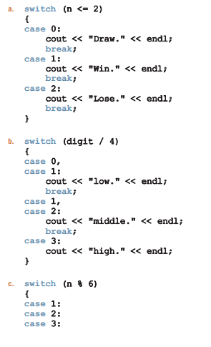

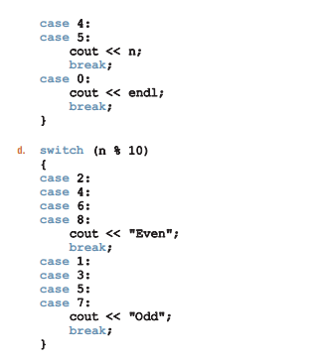

1. In the following code, correct any errors that would prevent the program from compiling or running.

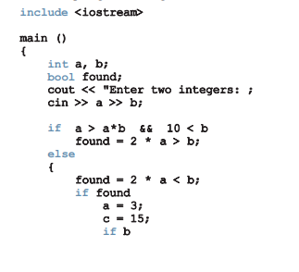

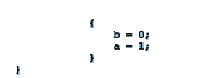

# **Section 4:**

# **Problems With Dry Runs**

1. What is the output of the following program?

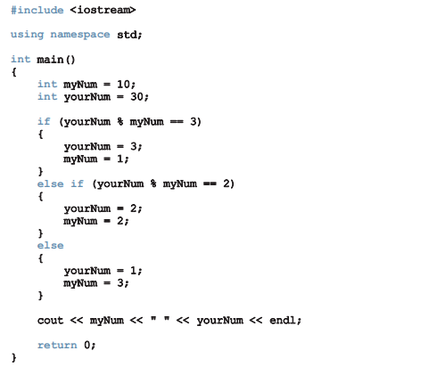

1. What is the output of the program, if **myNum = 5** and **yourNum = 12**?
2. What is the output of the program, if **myNum = 30** and **yourNum = 33**?
3. Suppose the input is 3, 5 and 10. What is the value of beta after the following C++ code executes?

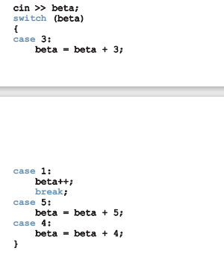

1. Suppose that x, y, and z are int variables, and x = 10.2, y = 20.8, and z = 50.6. Write a single C++ code to determine whether the following expressions evaluate to true or false.

* !(z > 10)
* x <= 5 || y < 15
* (x != 5) && (x != z)
* z >= x || (x + y >= z)
* (x <= y - 20) && (y >= z*2) || (z/2 - 2 != 20)